**Stream Assignment**

**Q1)** **Create the following classes:**

**class Fruit { String name; int calories; int price; String color; }**

**Display the following:**

**1. Display the fruit names of low calories fruits i.e. calories < 100 sorted in descending order of calories.**

**2. Display color wise list of fruit names.**

**3. Display only RED color fruits sorted as per their price in ascending order.**

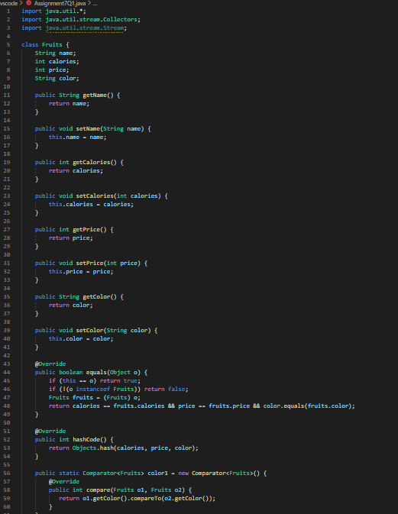

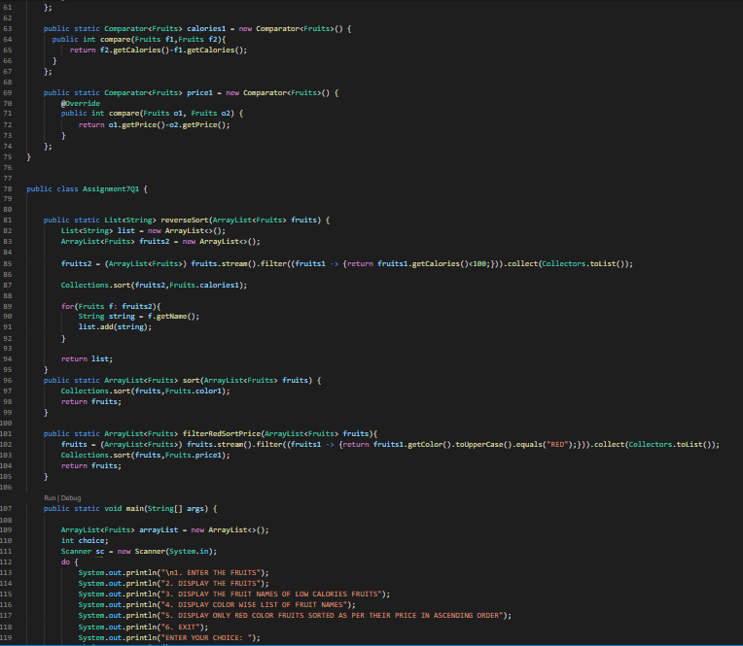

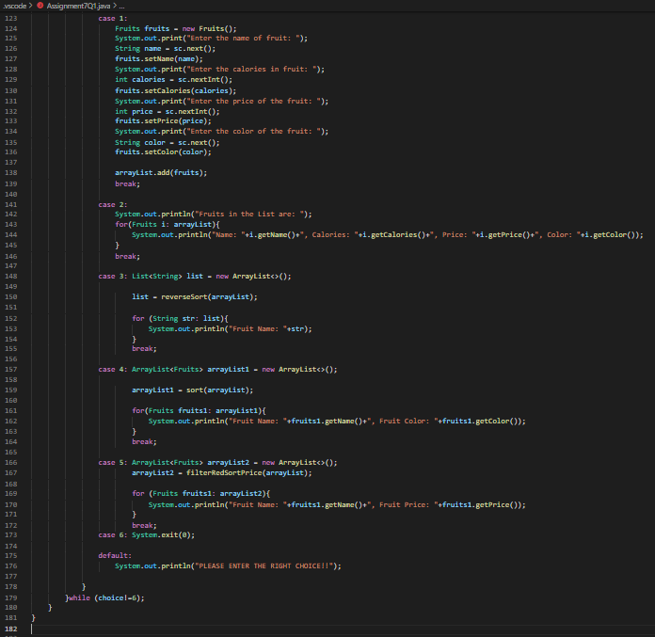

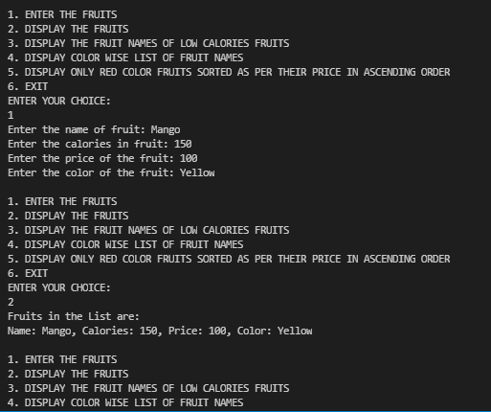

**Q2)** **Setup:**

**Create the following classes:**

**class News { int newsId; String postedByUser; String commentByUser; String comment; }**

**Find Out:**

**1. Find out the newsId which has received maximum comments.**

**2. Find out how many times the word 'budget' arrived in user comments all news.**

**3. Find out which user has posted maximum comments.**

**4. Display commentByUser wise number of comments.**

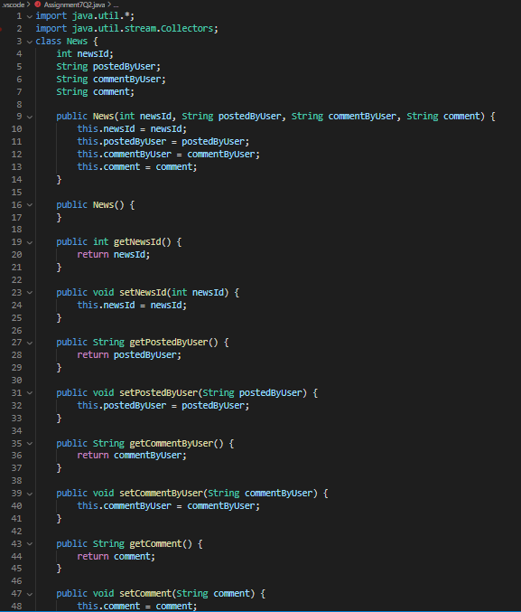

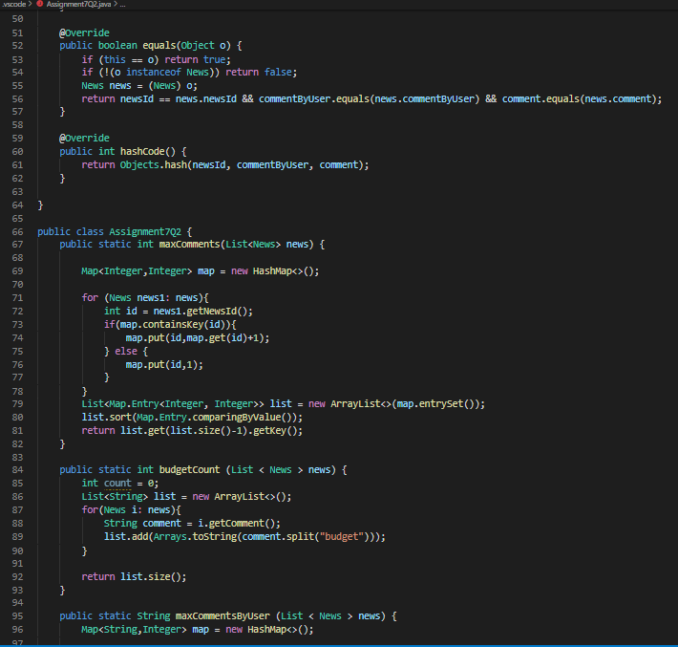

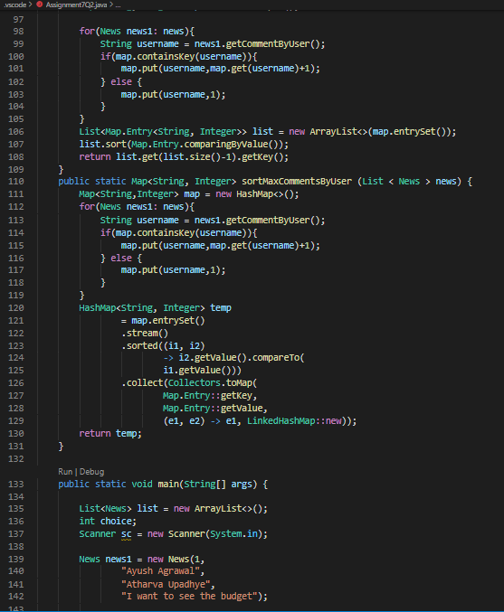

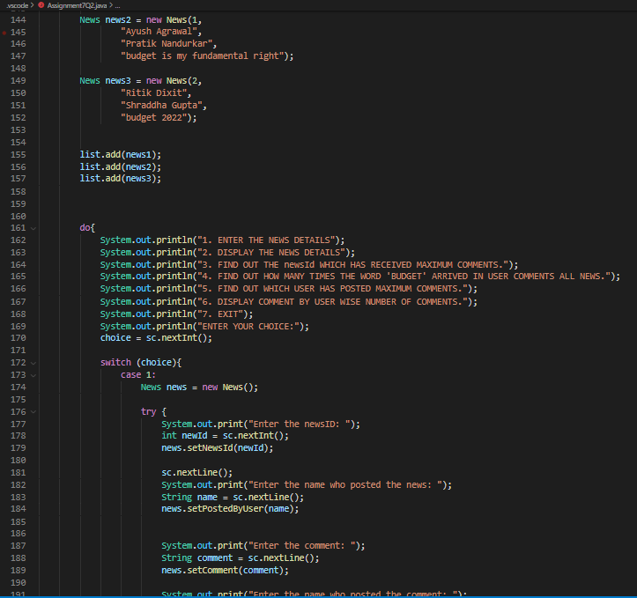

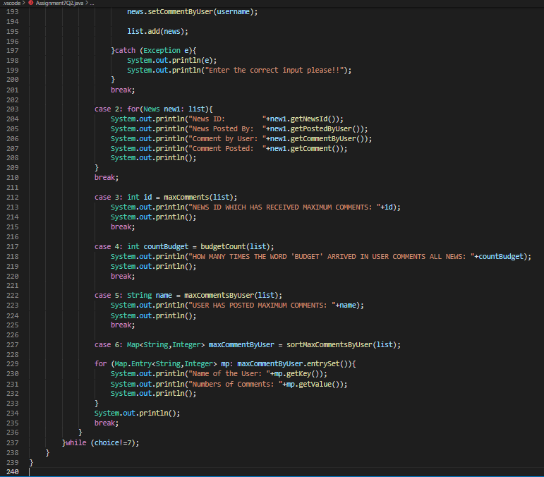

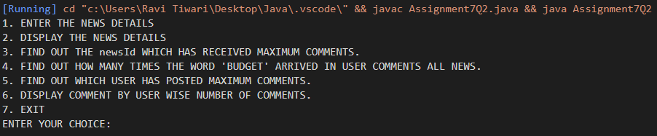

**Q3)** **Setup:**

**Create the following classes:**

**class Trader { String name; String city; }**

**Find Out:**

**1. What are all the unique cities where the traders work?**

**2. Find all traders from Pune and sort them by name.**

**3. Return a string of all traders’ names sorted alphabetically.**

**4. Are any traders based in Indore?**

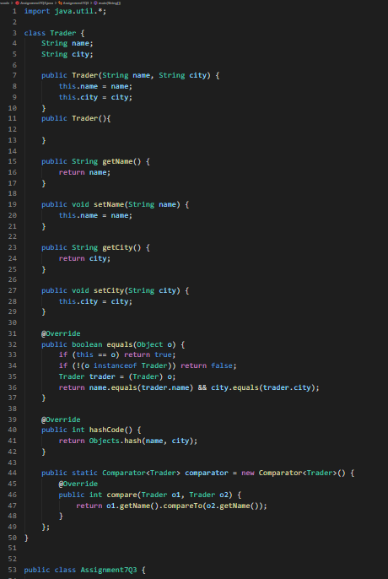

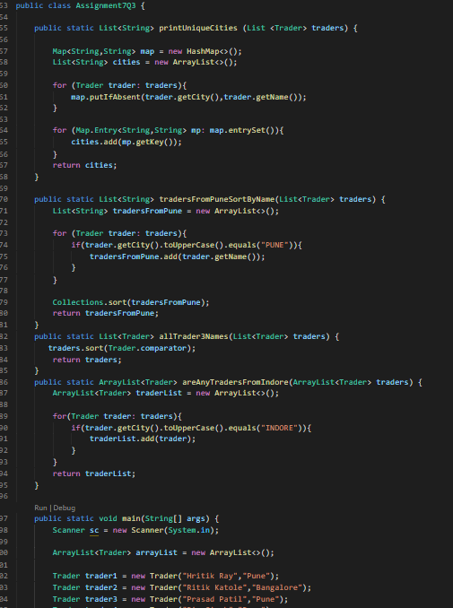

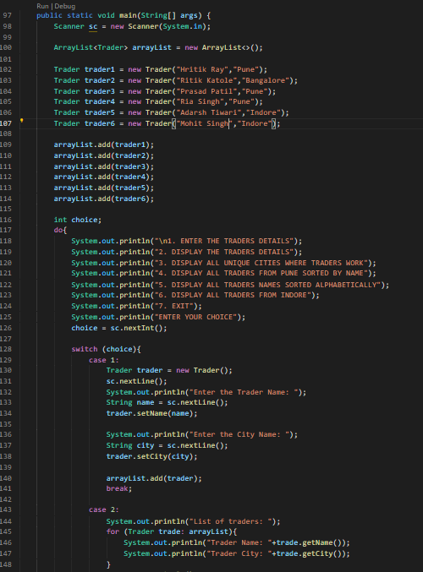

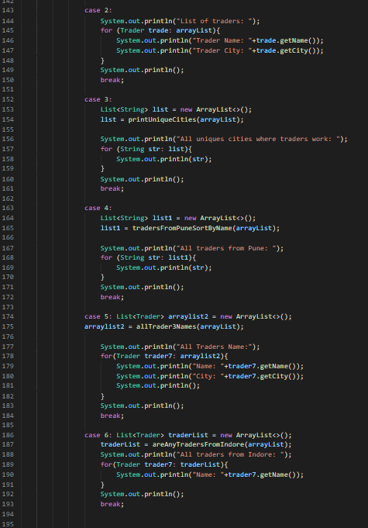

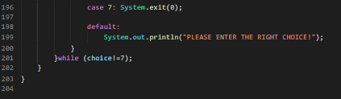

**Q4) Setup:**

**Create the following classes:**

**class Trader { String name; String city; }**

**class Transaction { Trader trader; int year; int value; }**

**1. Find all transactions in the year 2011 and sort them by value (small to high).**

**2. Print all transactions’ values from the traders living in Delhi.**

**3. What’s the highest value of all the transactions?**

**4. Find the transaction with the smallest value.**

